Test transactions re arch
Author/s: Sarthak Sharma
Team/Pod: Payouts Reliability| BU: X
Published Date:

Reviewer Name | Reviewed Date | Status

Table of Contents

1. Problem Statement 2
2. Introduction & Scope 3
2.1. Relevant Resources 3
3. Out of Scope 3
4. Futuristic Scope 3
5. Assumptions, Goals & Non-Goals 3
5.1. Assumptions: 3
5.2. Goals: 3
5.3. Non-Goals: 4
6. Current Architecture / Current HLD 4
7. Final Approach - Specifications 4
7.1. List of Possible Solutions 4
7.2. Assumptions 4
7.3. Possibility of Open Sourcing 5
7.4. Possibility on Patent 5
7.5. Data model/Schema Changes 5
7.6. Business Logic Changes 5
7.7. Miscellaneous Questions 5
8. Non Functional Requirements (NFRs) 6
8.1. Scalability 6
8.2. Availability 6
8.3. Security 6
8.4. Compliance 6
8.5. Reliability 6
8.6. Infra Cost 6
9. Feature Dependencies & SLAs 6
9.1. Upstream Dependencies 6
9.2. Downstream Dependencies 6
10. Testing Plan 7
10.1. Test Cases 7
10.2. UAT Testing 7
10.3. Performance/Load testing 7
11. Go-live plan 7
11.1. Production Rollout and Ramp plan 7
11.2. Backward Compatibility 7
11.3. Rollback plan 7
12. Monitoring & Logging 8
13. Milestones & Timelines 8
14. Glossary 8
15. Appendix 8

💡Note

Read following docs to get expert on different topics -
- Format and Structure Your Doc
- How to document code in Google Doc
- API Design Guide
- Put Google Doc in Presentation Mode

Full Reading List - Link

1. Problem Statement
Test transactions are payouts which are used to detect uptime. It generates some volume of traffic in order to detect uptime. The transactions are b/w two razorpay’s accounts.

We send test payouts to the bank in order to detect if the bank has reached a stable state again or not. We keep firing test payouts in an interval of time(3 mins) till we detect uptime.
As of now test transactions setup is present in Stage environment(Roast) and triggered via spinnaker pipeline. Also, test transactions have more use cases which are more complex to solve via roast for example - Holiday Management.

The idea here is to make test transactions as production ready functionality to make it stable and reliable as we are dependent on spinnaker and stage infra.

2. Introduction & Scope
- Move out of Roast -
  - Test transactions run on staging infra. Need to remove this dependency.
- Move out of spinnaker
  - Remove dependency from spinnaker as if spinnaker goes down we won’t be able to detect uptime.
- Holiday Management for test txns
  - Test transactions should not run during a holiday. This case is specific to NEFT payouts. NEFT payouts are queued for the next working day if the merchant creates a payout during non- working hours or holidays.
- Test txns should not impact live traffic
  - Test txns should not choke live traffic. This has a direct impact on SLA’s if the queue is filled with high number of test transactions
- Limit number of webhooks to payouts
  - FTS sends webhook to payouts on receiving status from the bank. Sending a high number of webhooks may impact merchant balance locks at payouts end.

2.1. Relevant Resources

3. Out of Scope
- Source Account level Downtime

4. Futuristic Scope

5. Assumptions, Goals & Non-Goals

5.1. Assumptions
Add what assumptions you’re making while coming up with the goals and non-goals

5.2. Goals
- Stable test transactions environment
- Self healing mechanisms
- Extensible modules for any future requirements
- Manual handling for starting and stopping test transactions

5.3. Non-Goals

6. Current Architecture / Current HLD
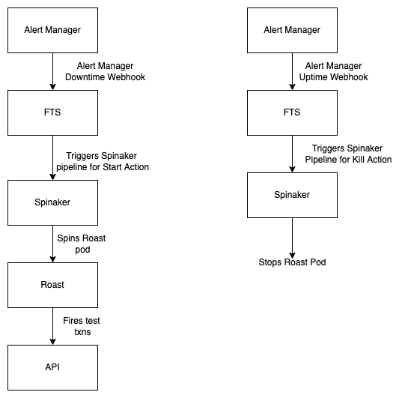

7. Final Approach - Specifications

7.1. List of Possible Solutions

Approach 1 (Goals1,2 & 3) -

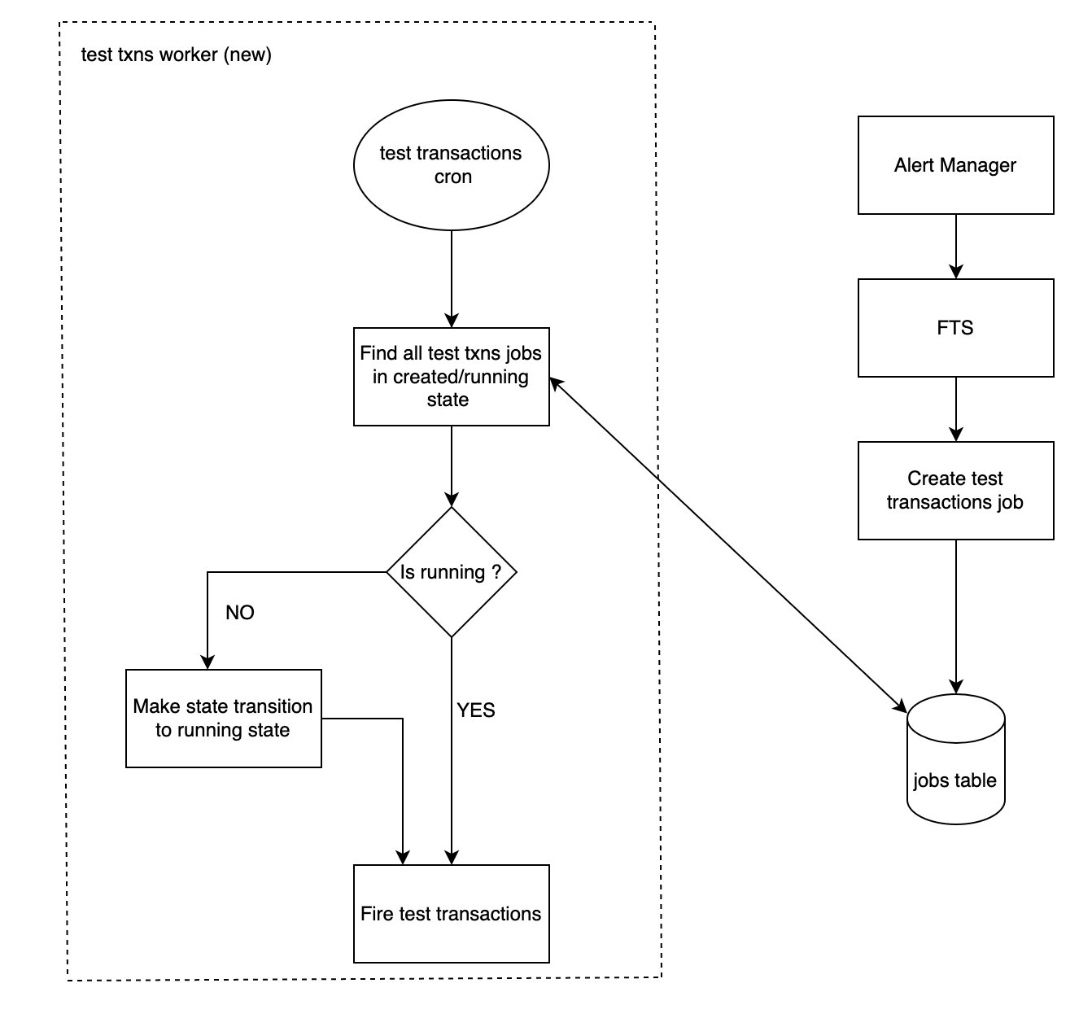

Cron Implementation

Leader election bw crons running in each pod

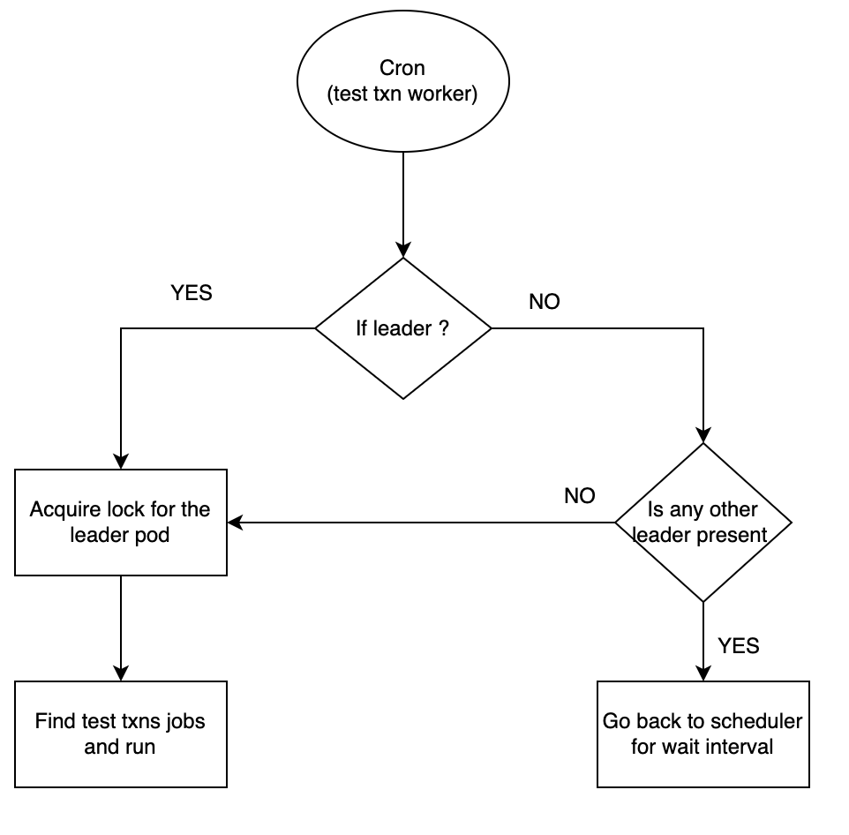

Why do we need a leader election here ?
We don’t want cron running in each pod to fire test transactions. Only one pod will be responsible for firing cron jobs till it is the leader of the lot. If cron for test transaction in each pod fires test transaction then we will fire an extra number of test transactions, that is why we require leader election
In this scenario we will only have one pod in each cluster. One of them will become the leader on FCFS basis

How is the leader elected ?

From the above diagram, you can see the cron keeps checking if that pod is the leader or the leader pod is down.
We have to generate a unique key on bootstrap to associate with the worker. This worker's unique id will be mapped to a key in redis.
We will find the leader with the help of generated unique id.
If the leader pod is down/key is not present in redis then it makes itself the leader. If the key is present and that pod is the leader, the cron will run the jobs that are in the START state as explained in the above diagram
The leader keeps updating the redis key TTL in order to maintain its position as a leader.

Why do we choose Go cron over Cron Job?
- CronJob is an external service. We do not want our test transactions to be dependent on external service as downtime of CRON will directly impact routing in FTS. So test transactions become critical part of the system
- Everyone does not have access to the Cron Job in the team. In case any changes or manual intervention required we may have to be dependent on that person. We want to build the capability internally so that on-call can resolve the issue if manual intervention is needed.

Execution Strategies
- 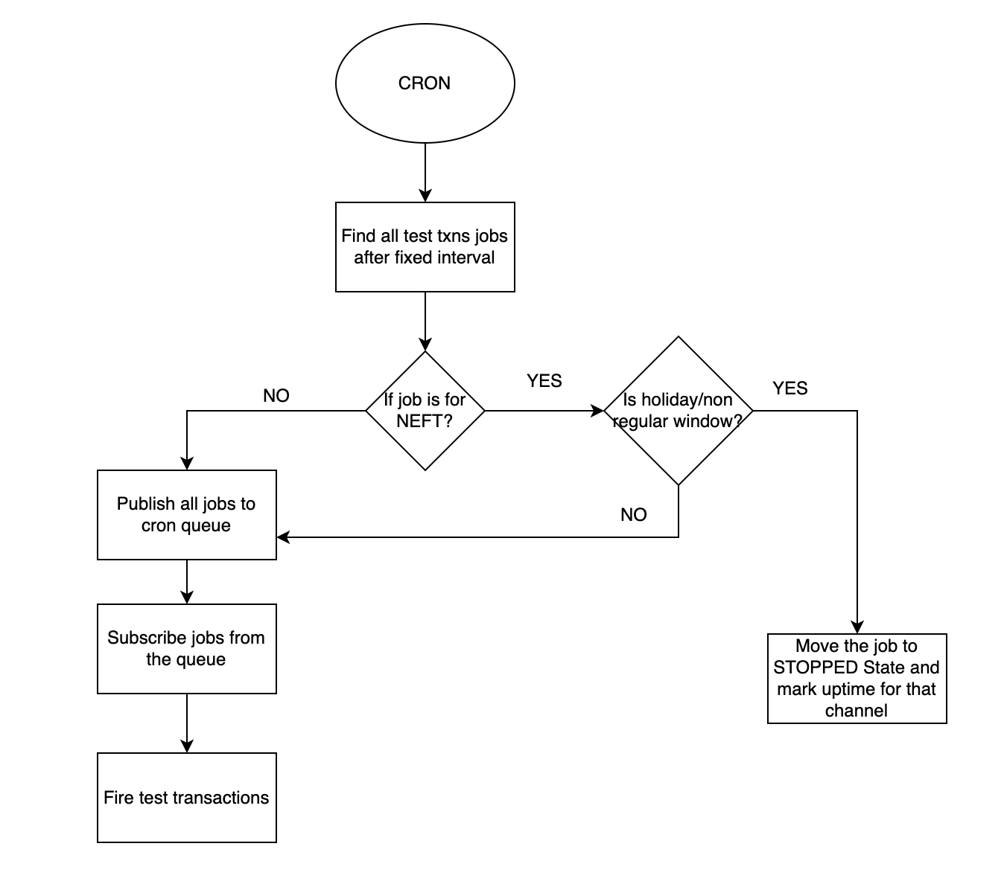
  - Pick all the test transactions Jobs that are in the STARTED state.
  - Push all the jobs in the queues with relevant delays.
  - Publish the job to a queue(Most likely redis queue).
  - We will control the overall rate of all jobs/test transactions hitting payouts via task consumption rate for that task(tcr still to be decided).
  - Message drop from the queue will not impact us in a very great manner as the cron will keep pushing jobs for running test transactions.
  - Cons
    - Redis becomes a single point of failure.

Polling strategies for Cron
- Firing only one event at each poll for every job in STARTED State
  - Pros
    - Easy to implement.
    - No custom logic required for firing test transactions
  - Cons
    - In case multiple channel degradation, it may consume time more that expected
    - High number of queries in a very short interval of time. For example in case of test transaction every 4 secs cron will scan the table
- Firing Events in Bulk at once
  - Pros
    - Less number of queries on cron jobs table
    - In case of multiple degradations it will be able to process all the request in a large time span
    - Custom logic for firing test transactions job executor
  - Cons
    - Sending traffic to payouts in bursts may impact the payouts API. We have to handle throttling in this scenario.

How is throttling handled in such a scenario ?
- We will use task consumption rate to handle throttling. Number yet to be decided.
- In case of firing events in bulk, we will distribute them over a period of time using delays while pushing jobs in the queue
TPS per integration - 50 payouts in 3 mins - 0.27
Total API integrations - 27
Worst case - Max TPS that may be required if all integrations are down together - 27*0.27 ~ 7 TPS (We will throttle it to a lower threshold)

Approach 1 (Goal 4 & 5)

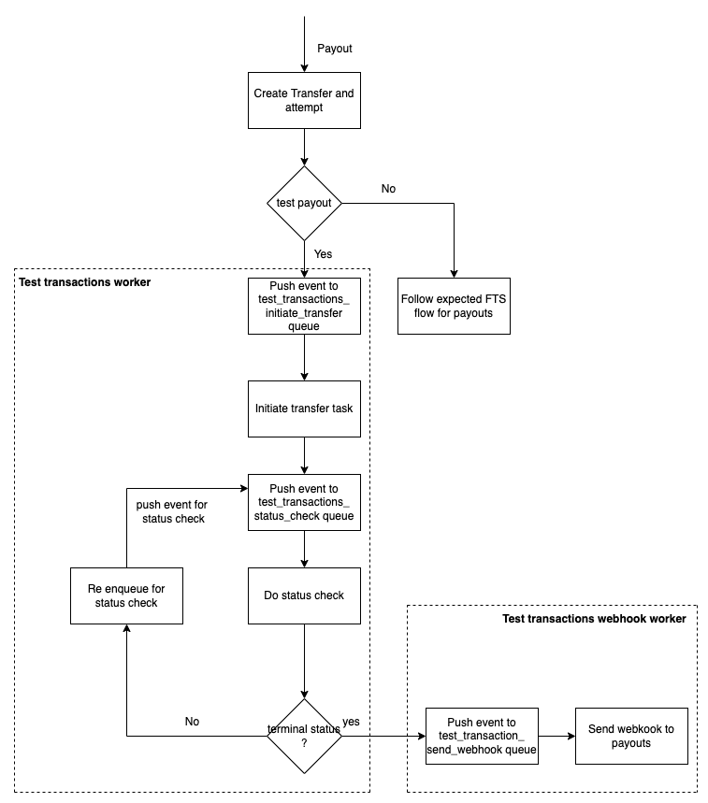

How are we removing the impact on live traffic ?
We are creating a new test transaction worker and queue for handling test transactions. As the total count of test transactions is fairly low it won’t breach bank’s throttling limit.
Note : This worker is also responsible for starting and stopping test transactions as well

How are we limiting the number of webhooks to payouts ?
Limiting the number of webhooks is achieved by creating a new worker for webhooks. This will be a short term solution. This will be covered in merchant level throttling as a long term solution.

Why are we creating a new worker for limiting webhooks ?
We want to achieve lower TPS for handling webhooks sent to Payouts. While test transaction worker will have high consumption rate as it is handling live traffic and start/stop test transactions as well

7.2. Assumptions
Add assumption

7.3. Possibility of Open Sourcing
NA

7.4. Possibility on Patent
NA

7.5. Data model/Schema Changes
New table - scheduler/cron_jobs
New column in channel_information_status
- scheduler/jobs- This table is responsible for storing information for test transactions. It holds the status as well as the relevant information needed for test transactions to run.
ID | source_id | Status | Module | request | meta

Status (varchar) - CREATED, STOPPED
Module (varchar)- eg: test_trasaction_module
Request (JSON)
Meta - Job meta. For eg: Storing merchant_id in case of test transactions.
Source_id - It will be the idempotency key for identifying jobs uniquely

- Adding a new column in the channel_information_status table.
entity_id - varchar(10). Unique Id generated of length 10.

7.6. Business Logic Changes

LLD and changes in business logic to be added

7.7. Miscellaneous Questions
Answer questions if only relevant, add more questions as required
- What are the limitations of the solution?
- How will it recover in the event of a failure?
- How will it cope with future requirements?

8. Non Functional Requirements (NFRs)
Talk about each as applicable and call out the expectations/risks from the feature.

8.1. Scalability

8.2. Availability

8.3. Security

8.4. Compliance

8.5. Reliability

8.6. Infra Cost

9. Feature Dependencies & SLAs
Callout upstream and downstream applications that will get impacted

9.1. Upstream Dependencies
Add SLO/SLA dashboard links for existing services.
Sr. No. | Service | Impact | SLA (if applicable) | POC for service
1 | abc |  |  | Owner/expert on abc

9.2. Downstream Dependencies
Sr. No. | Service | Impact | SLA (if applicable) | POC for service
1 | xyz |  | TBD | Aditi Maheshwari

10. Testing Plan
Lay down test scenarios

10.1. Test Cases
(UTs, ITs, regression suites, UI/UX tests and manual test efforts)
Capturing the results with upstream and downstream applications and validating the results against expected outputs

Add links here only.

10.2. UAT Testing
Capturing User acceptance test results, validating against genuine data

10.3. Performance/Load testing
Capturing any load testing that we wish to perform

11. Go-live plan

11.1. Production Rollout and Ramp plan
Add what will be done to progressively roll out the feature in production. You can take cues from product spec also to see how we can support the ramp up whether in a phased manner, in one shot or through certain gating criterias as needed.

11.2. Backward Compatibility

11.3. Rollback plan
Add what will be done in case of an immediate rollback requirement and how it will be implemented.

12. Monitoring & Logging
Jot down all metrics that need to be monitored for the changes being made

13. Milestones & Timelines
Breakdown the task into major milestone, divide the milestones to further task and subtask, mentioning owners, JIRA/Asana link, due date, reviewer, status
Creating a tabular sheet in excel is preferable here for better understanding
Please paste the link for the tracker with details similar to below here

Sr. No. | Title | Owner | JIRA/Asana link | Due Date | Reviewer | Status
1 | Move test transactions traffic to test transactions worker | Sarthak Sharma
2 | Creating worker and task to start/stop test transactions | Sarthak Sharma
3 | 100% ramp up on the new test transactions worker | Sarthak Sharma
4 | Limit number of webhooks by adding new worker | Sarthak Sharma

14. Glossary

This section describes all the terms and abbreviations being used specifically in the context of the above feature and heavily being used in this document.

15. Appendix

This section provides the links to all other important documents such as Project Milestone trackers, PRDs (created by Product team), Concept notes, JIRA/Asana project links and any other relevant links.

- Razorpay Product: Concept Note Template <June 2022>
- https://stackoverflow.blog/2020/04/06/a-practical-guide-to-writing-technical-specs/
- https://www.thecloudtutorial.com/technical-specification-document/

